MLC EVENT:
Orlans Group
October 14, 2016
AGENDA

Registration: 12:30 – 1:00 pm
Main Event: 1:00 – 4:30 pm @ Orlans Group 1650 West Big Beaver Road Troy, MI 48084
*After Event Networking: Networking session directly after at the Orlans Center. They will provide drinks and appetizers.

Program Title / Synopsis (Click on the links to read entire bios):
- Orlans Group Lean Journey, Brian Henry and Greg Avesian, Director of Business Process Solutions
- Lean from an Attorney's perspective, Brian Henry, Chief Legal Officer
- Lean's impact on Company Culture, Mark Albrect, Senior Director Human Resources
- Lean from a Real Estate Perspective, Regina M. Slowey
- Improving Legal Service delivery, Daniel Linna
Two breakout sessions:
Will be facilitated by members of the Orlans Group Management team where participants will share their best practices around the two topics:
- Gemba Walk
- Culture Change/Engaging the workforce
We want to explore the following in the breakout sessions:
- What are some of the successes companies have achieved around these two topics?
- How did they achieve their success?
- Approach
- Technique
- Methodology
- What are the critical success factors?
Program Learner/Participant Objectives: Education, Networking, Sharing Best Practices
Targeted Audience: MLC members from all industries and experience levels

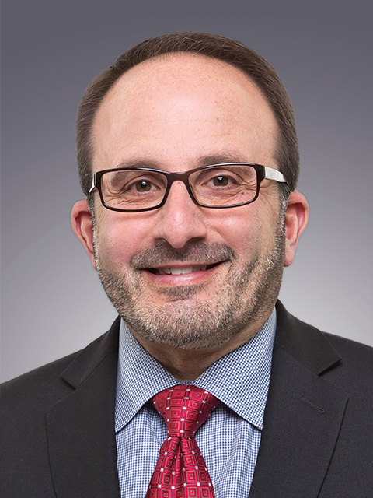
Greg Avesian
Director, Business Process Solutions
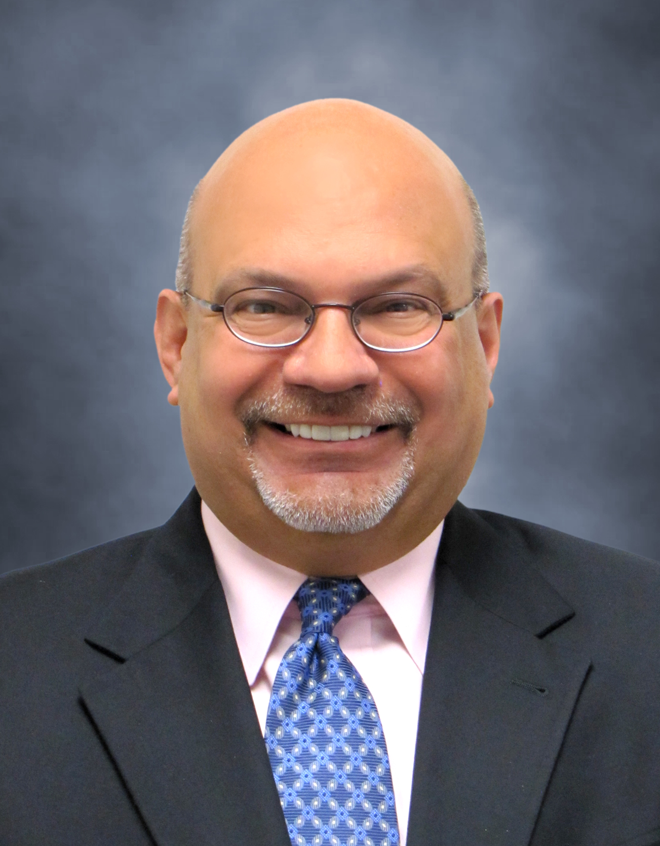
Greg Avesian has over 25 years of experience implementing process improvements throughout the Automotive, Aerospace & Defense, and Legal Service industries. He currently serves as the Director of Business Process Solutions for eVantage Services, a shared service function supporting the Orlans Group of companies. In this role, Greg is leading the training & implementation of Lean Six Sigma throughout the organization. He previously served as Director of Information Systems for Burtek Inc., a military defense contractor serving the aerospace & defense industries. Mr. Avesian has also served in leadership roles at Textron, Inc. and Chrysler Corporation.

Mark J. Albrecht
Senior Director, Human Resources
Mark Albrecht serves as the Senior Director, Human Resources for the Orlans Group. Prior to joining the firm he was Senior Vice President of Human Resources with RGIS, a Blackstone Company. Mr. Albrecht has over 30 years of executive leadership positions in human resources and operations with both retail and professional service companies including Lord & Taylor, Ann Taylor, Britches of Georgetowne and Handleman Company. He has served in Human Resources leadership positions for over 24 years.
brian Henry, esq.
Chief Legal Officer
Brian Henry serves as Managing Attorney for Orlans Associates and brings over 32 years of expertise in real estate law, business law and commercial litigation to the team. Mr Henry’s responsibilities include creating strategic relationships, identifying business opportunities in the title insurance industry and supervising closings.
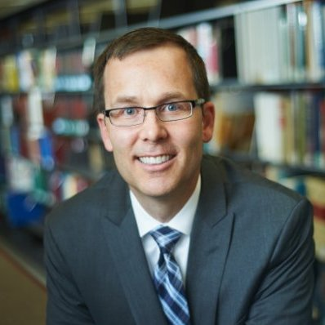
Daniel Linna
Daniel W. Linna Jr. is the Director of LegalRnD – The Center for Legal Services Innovation and a Professor of Law in Residence at Michigan State University College of Law. Previously, Dan was an equity partner in the litigation department at Honigman Miller Schwartz and Cohn. He was also a member of Honigman's Automotive and Manufacturing; e-Discovery and Information Management; Commercial Transactions; and Social, Mobile, and Emerging Media groups. Dan joined Honigman after clerking for U.S. Court of Appeals Judge James L. Ryan. Before law school, Dan was an information technology manager, developer, and consultant. He is the co-founder of and lead organizer for the Detroit and Chicago Legal Innovation & Technology meetup groups. Dan received his BA from the University of Michigan, a second BA and an MA in public policy and administration from Michigan State University, and his JD from the University of Michigan Law School.

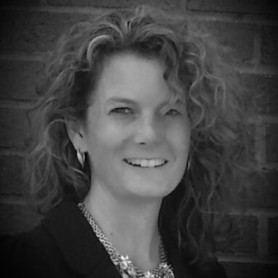
Regina m. slowey
University of Michigan Law School, J.D.; University of Michigan Honors College, B.A. Ms. Slowey specializes in real estate law. She has handled and resolved title claims and issues for the past ten years, in private practice on behalf of commercial and individual clients, title agencies, and currently for Orlans Associates, P.C. Prior to private practice, Ms. Slowey served as in-house counsel to a mortgage lender with a presence in over 30 states and as a judicial law clerk to the Honorable William J. Saad of the Michigan Court of Appeals, and the Honorable John Feikens of the Eastern District of Michigan. Ms. Slowey is licensed to practice in Michigan and California. Regina Slowey has been a licensed attorney since 1999.
Description | Presenter | Time
Registration | MLC | 12:30 – 1:00
Welcome  - MLC Welcome & Overview  - Overview of session (Greg)  - Welcome message (Alison) | MLC Board member  Greg Avesian  Alison Orlans | 1:00-1:15
Keynote Address  - Orlans Group Lean Journey | Brian Henry  Greg Avesian | 1:15 – 1:45
Lean from an Attorney’s perspective | Brian Henry | 1:45 – 2:00
Lean from a Real Estate perspective | Regina Slowey | 2:00 – 2:15
Break for Networking | All | 2:15 – 2:30
Improving Legal Service delivery | Dan Linna – MSU College of Law | 2:30 – 2:45
Breakout sessions led by Orlans Operational Leaders to brainstorm Lean Management Best Practices.  - Gemba Walk (Kate/Anne)  - Culture Change/Engaging the workforce (Mark) | Anne Linder  Kate Berdych  Mark Albrecht | 2:45 – 3:30
Break for Networking | All | 3:30 – 3:45
Present Break-out session best practice recommendations | Group Leaders | 3:45 – 4:15
Closing Remarks | Greg Avesian and MLC Board member | 4:15 – 4:30

Thank you to Orlans Group for sponsoring this event!

