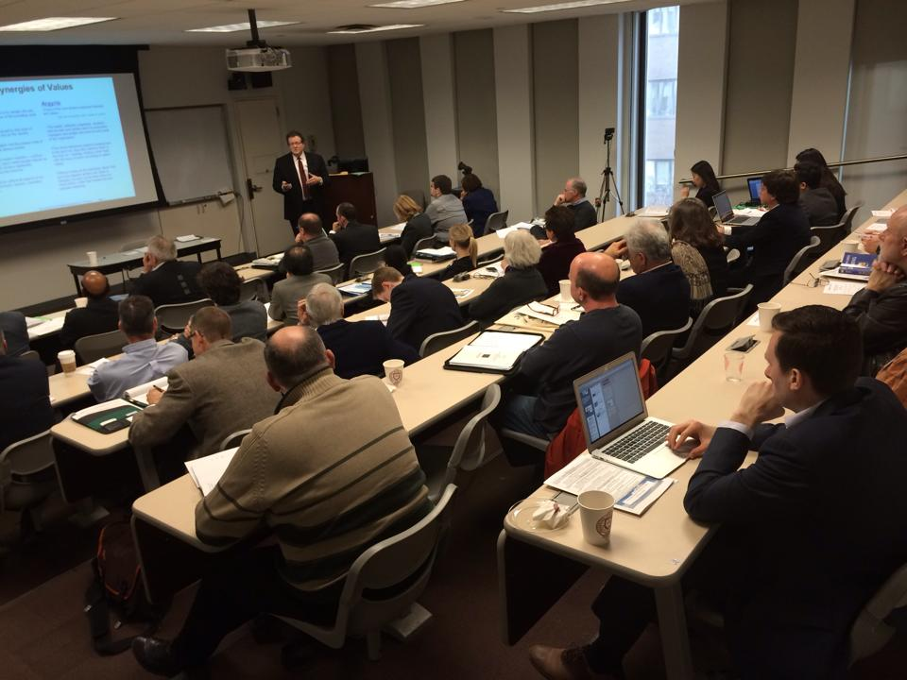

On March 4th this year, Dennis Sergent presented his paper "Argyris, Deming and Transformation - Our Values in Action Will Transform Us" at Fordham University in New York City as part of the 20th Annual International Deming Research Seminar (see photo). This was co-sponsored by the Fordham University GBA, the W. Edwards Deming Institute and The Deming Cooperative.

In addition to his role as the MLC Vice Chairman, Dennis has been a long time student of W. Edwards Deming and Chris Argyris, a Harvard Sociologist. His study of transformation in organizations has brought him to understand much of W. Edwards Deming’s System of Profound Knowledge (SoPK) and the synergies between the work of Deming and many other thinkers, such as Chris Argyris. Their work resonates strongly in philosophy and themes on transformation. Like many philosophers and social scientists, Argyris has perspectives about organizational transformation through understanding systems, the people in them and the power of shared purpose.

"It was a humbling experience to participate in this seminar and speak on these synergies between Deming and Argyris. To speak before so many experts and authors of research about quality, productivity, ethics was sobering. To be able to speak before the Deming family, the former chairman of the FCC and these experts was a peak of my professional life. And it was quite fun to learn from the numerous other speakers and share something with them that they did not know."

"My thesis was that as leaders, we must transform ourselves to demonstrate skilled, competent action toward our common aims with our teams. In the context of these numerous areas of Argyris’ observations, it seems that we can transform organizations by transforming ourselves first. In his practice and writings, Argyris provided us hard evidence of Deming's points and provided actionable solutions that we can use with all of W. Edward Deming’s writings, philosophies and practices to make a difference in our work and the work of others."
Anyone in the MLC who would like to get a copy of the research or the slide deck on this can download them from the MLC website or contact Dennis directly.

